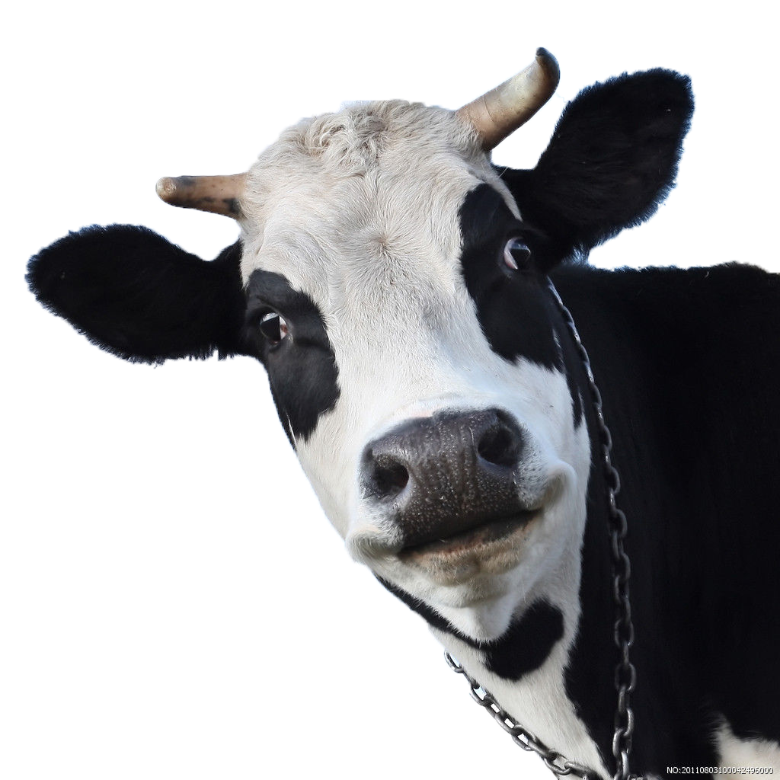
COW:Challenge Of the Week
This Photo by Unknown Author is licensed under CC BY-NC
Keep a To-Do List every day for a week.
Reflect on how this might have helped you in your personal or academic life!

